1. Define a class called Logger that takes the name of a file in its constructor and provides a method for writing messages to that file. Don’t worry about the actual file I/O operations. Just define the class with the right members.

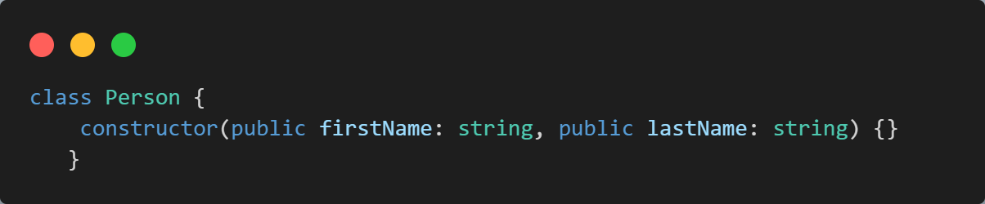2. Given the Person class below, create a getter for getting the full name of a person.

3. Create a new class called Employee that extends Person and adds a new property called salary.

4. What is the difference between private and protected members?

5. Given the data below, define an interface for representing employees:

